Table of Contents

Gotoro: Guideline to Setup build image on Oracle Visual Builder Studio 1

# Gotoro: Guideline to Setup build image on Oracle Visual Builder Studio

Step 1: Login Oracle Visual Builder Studio: [Welcome to Visual Builder Studio! (oraclecloud.com)](https://gotoro-gotorodev.developer.ocp.oraclecloud.com/gotoro-gotorodev/#?orgTab=projects). Chose project Gotoro-DevOps => Builds.

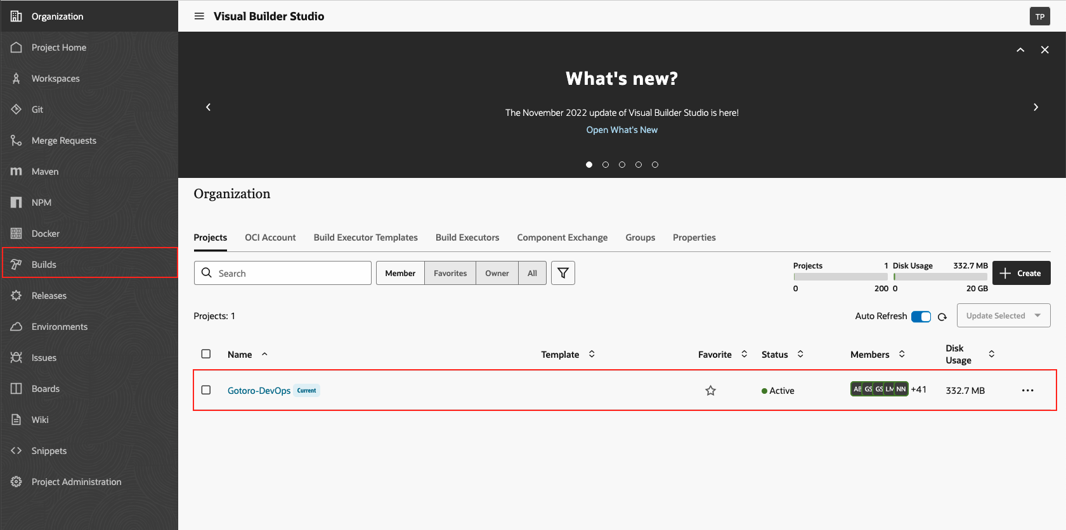

Step 2: Create job build.

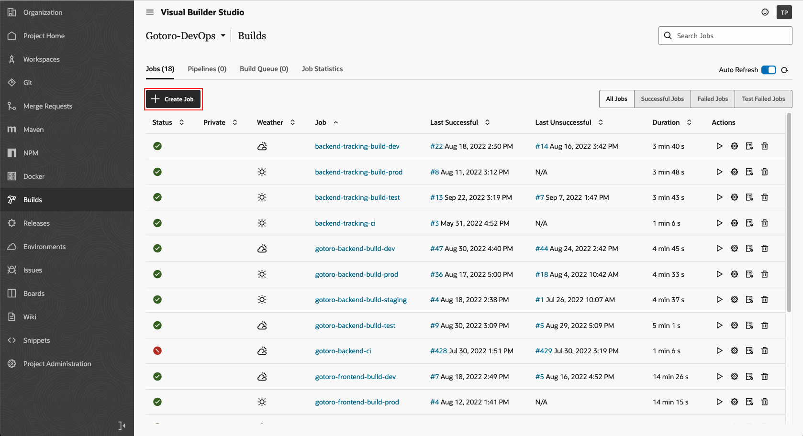

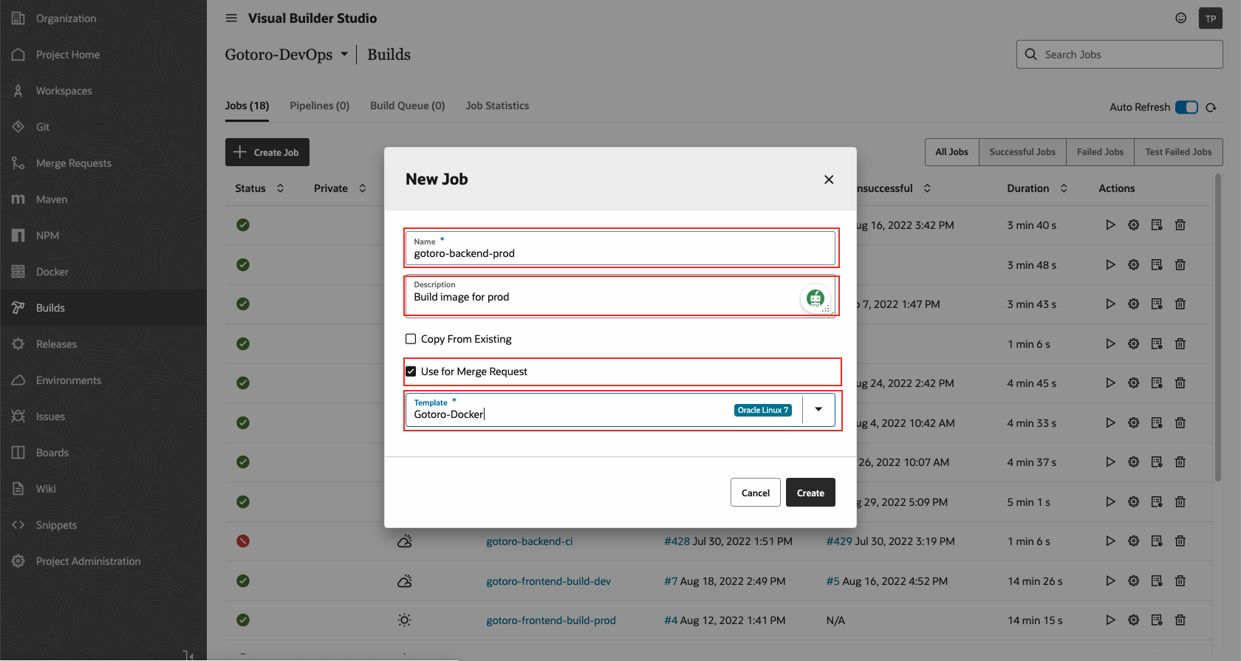

Step 3: Config Git**.**

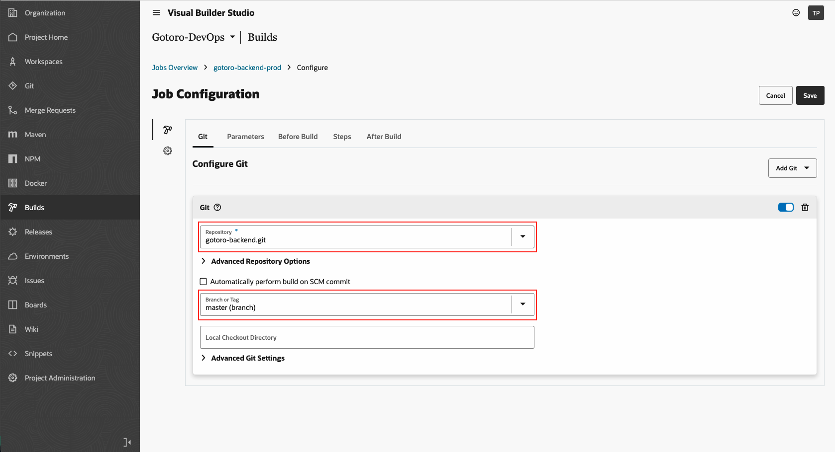

Step 4: Config Parameters.

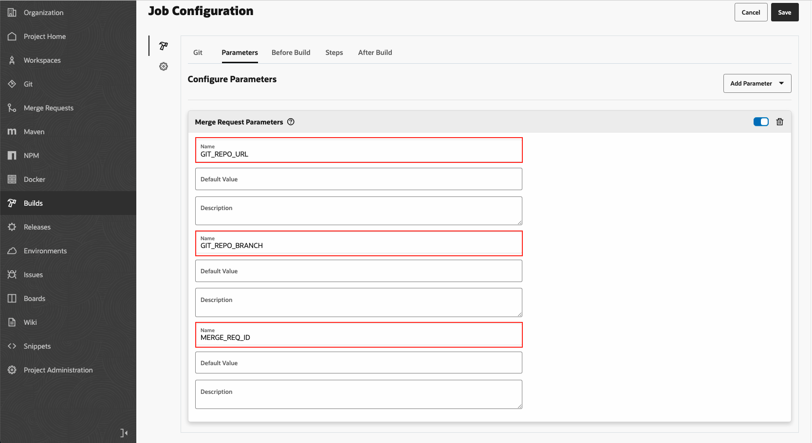

Step 5: Config Steps

Add Step docker login: Add Step => Docker login => Fill Registry Host and username(idapel7w8ikn/serviceaccount) password(DevOps@2022@!)

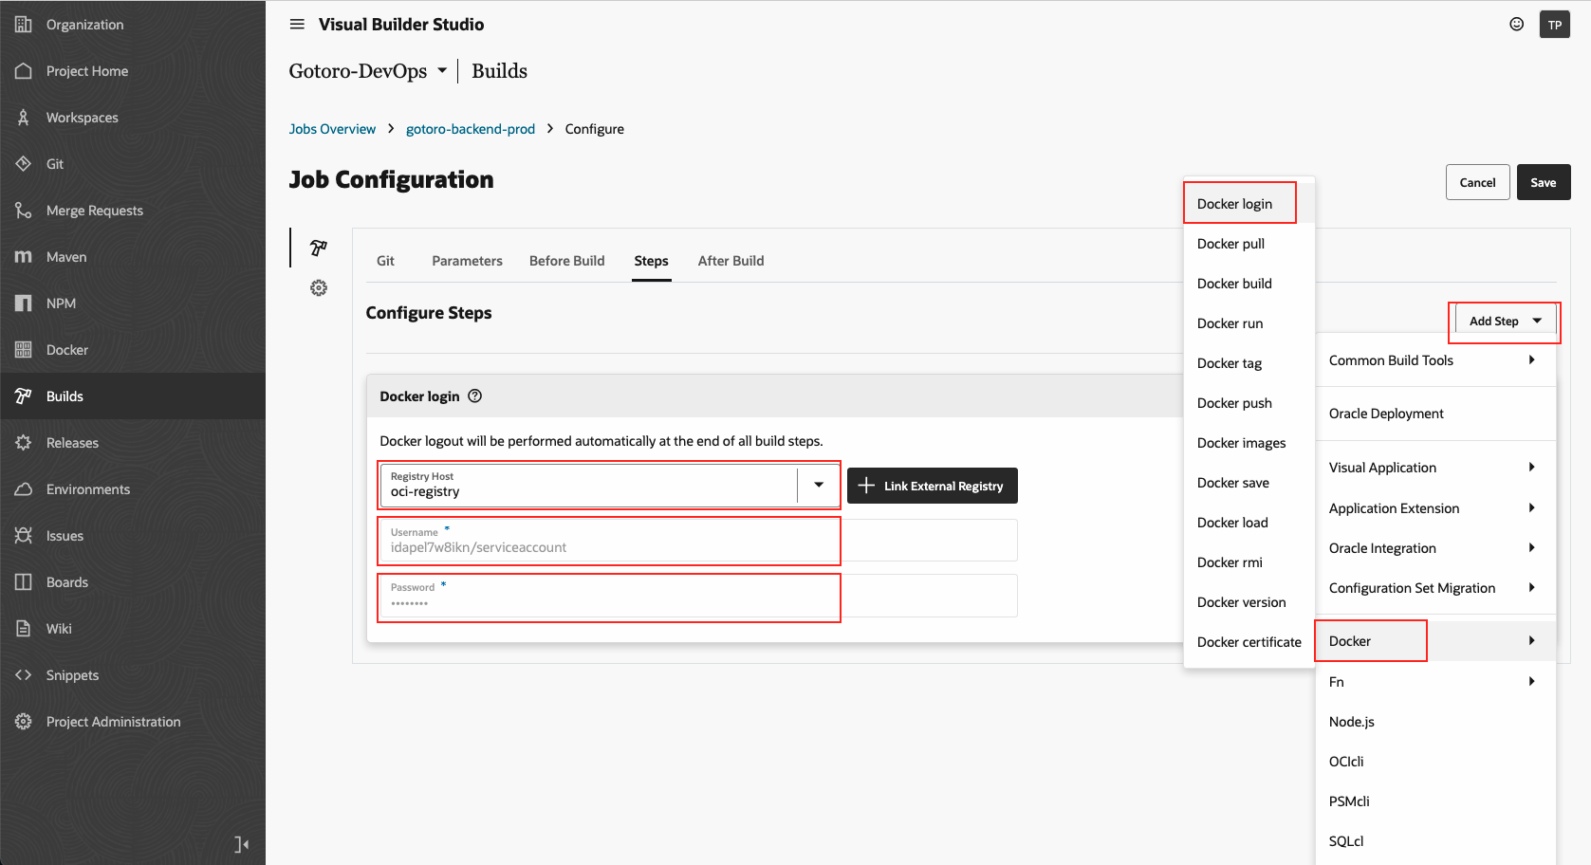

Add Step Unix Shell: Add Step => Common Build Tools => Unix Shell

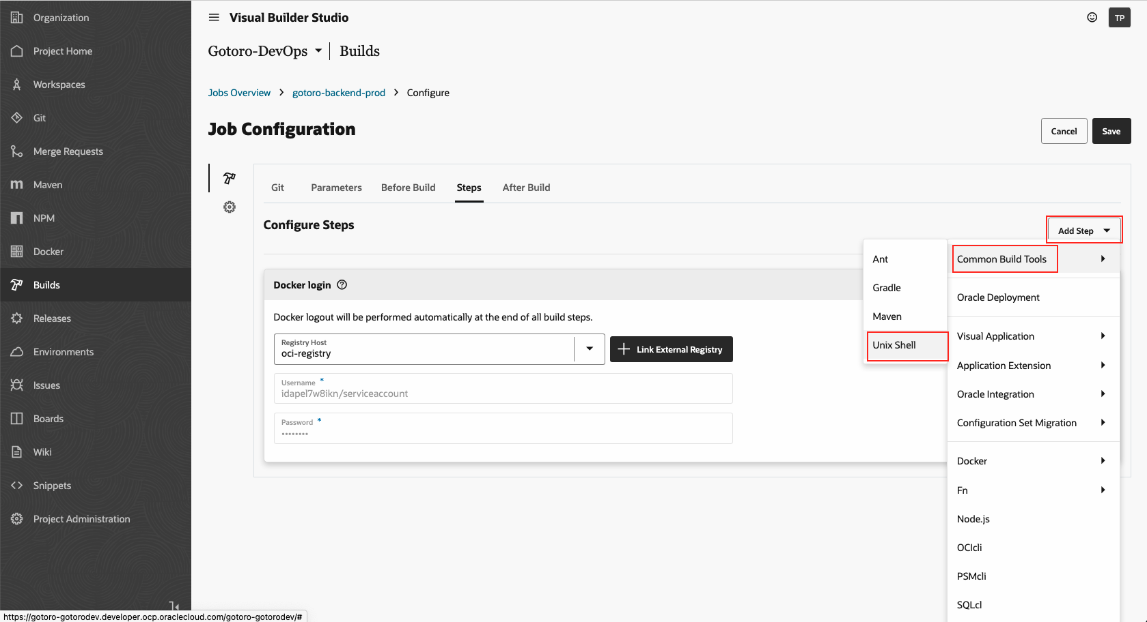

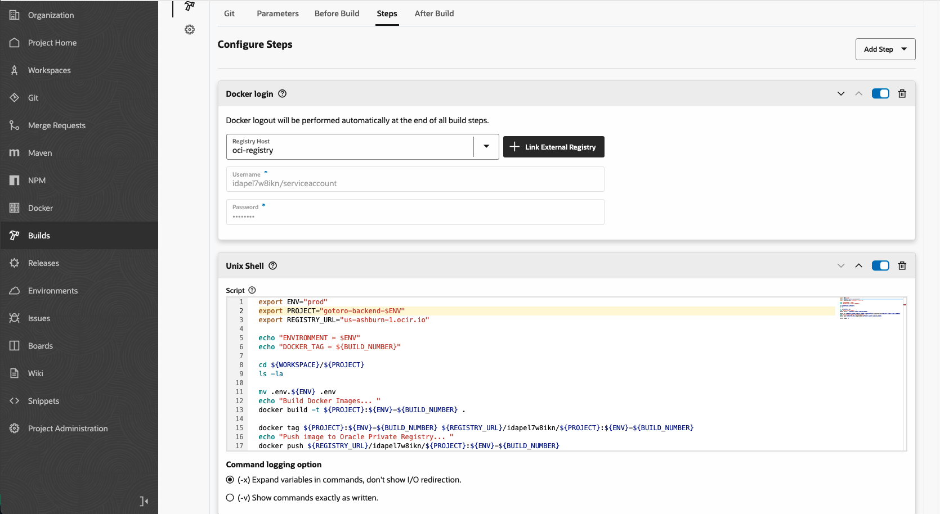

Unix Shell

export ENV="prod"

export PROJECT="gotoro-backend-$ENV"

export REGISTRY_URL="us-ashburn-1.ocir.io"

echo "ENVIRONMENT = $ENV"

echo "DOCKER_TAG = ${BUILD_NUMBER}"

cd ${WORKSPACE}/${PROJECT}

ls -la

mv .env.${ENV} .env

echo "Build Docker Images... "

docker build -t ${PROJECT}:${ENV}-${BUILD_NUMBER} .

docker tag ${PROJECT}:${ENV}-${BUILD_NUMBER} ${REGISTRY_URL}/idapel7w8ikn/${PROJECT}:${ENV}-${BUILD_NUMBER}

echo "Push image to Oracle Private Registry... "

docker push ${REGISTRY_URL}/idapel7w8ikn/${PROJECT}:${ENV}-${BUILD_NUMBER}

docker images -a

Step 6: Save

Click to Build to Start build images for Prod

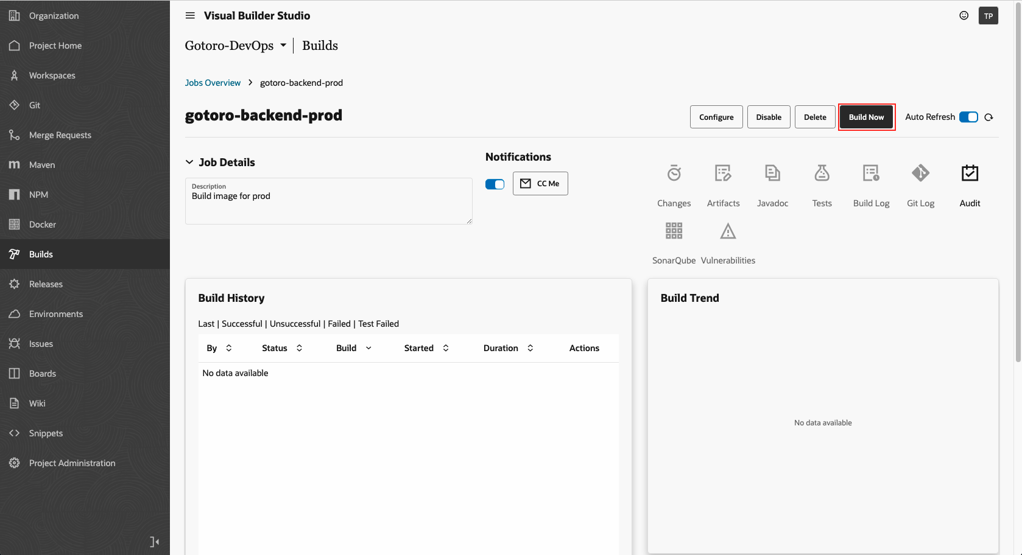

**End Guideline.**